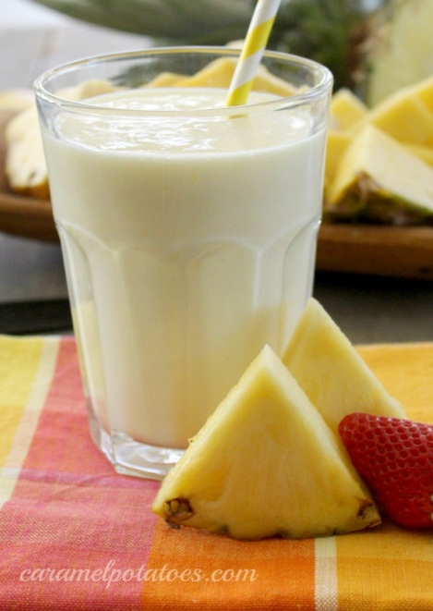
Smoothie Recipe
1 cup low fat or non-fat vanilla yogurt
5 ice cubes
1 cup fresh pineapple chunks
1 banana
½ cup frozen strawberries
Directions: Place all ingredients in a blender and blend.

Breakfast Burrito
1. Make scrambled eggs. Figure 1 egg per person in a group
1 Tbsp of milk per egg
Salt and pepper to taste
Margarine for the skillet

In a small bowl, combine eggs and milk. Add salt and pepper. Melt margarine in a skillet and then add eggs. As the mixture sets, gently scramble. Cook until the eggs are thickened and no visible liquid egg remains. Do NOT stir constantly.

2. Each group receives 5 strips of bacon. Fry and then crumble. Drain on a paper towel.

3. Each group recievs ½ cup grated cheese.

4. To assemble the burrito: (divide evenly with group)
1 flour tortilla
Scrambled egg
Crumbled bacon cheese
Salsa if desired
Roll the burrito and heat in microwave until cheese melts (approximately 30 sec.)

